Apriori-Based Analysis of Cybersecurity Attack Patterns
Anuja Indalkar, Bhakti Rode, Nikita Pal, Siddhi Bhosale, Pratik Ranvir, Ganesh Kubade
Department of Artificial Intelligence & Data Science (M.Sc. AI & Data Science)
Indira University, Pune, Maharashtra, India
Under the guidance of: Shubham Bende, Department of Artificial Intelligence & Data Science, Indira University, Pune

Abstract—Cybersecurity incidents contain many characteristics describing attack techniques, affected assets, and security impacts. This paper presents an Apriori-based analysis of cybersecurity attack patterns using the VERIS Community Database (VCDB). A total of 10,596 incidents and 66 selected attributes, drawn from an original set of 2,683 VCDB fields, were transformed into a binary transaction matrix. The Apriori algorithm, applied with a minimum support of 1% and a maximum itemset length of three, identified 1,183 frequent itemsets (54 one-itemsets, 287 two-itemsets, and 842 three-itemsets), from which 5,626 association rules were generated. After support–confidence–lift filtering (support ≥ 1%, confidence ≥ 70%, lift > 1), 2,744 meaningful rules and, subsequently, 1,901 attack-oriented rules were obtained; 12 representative rules were selected for detailed analysis. The strongest associations include Phishing → Alter Behavior (100% confidence, lift 15.05), Downloader → System (91.01% confidence, lift 45.49), and DoS → Availability Interruption (91.12% confidence, lift 30.85). The results show that Apriori-based association rule mining can uncover interpretable co-occurrence patterns among cybersecurity incident characteristics. The discovered rules describe statistical associations rather than causal or temporal relationships, and the study does not attempt kill-chain or attack-stage reconstruction.
Keywords—Cybersecurity, Apriori Algorithm, Association Rule Mining, Attack Patterns, VCDB, Support, Confidence, Lift, Data Mining
I. Introduction
A. Background
The growth of internet-connected systems, cloud services, and digital infrastructure has increased organizational exposure to cybersecurity threats. Reported incidents typically combine multiple characteristics — attack actions, affected assets, threat actors, and security impacts — whose relationships are not always evident from individual-incident analysis. Association Rule Mining (ARM) is a data-mining technique that identifies items that co-occur within a set of transactions, and the Apriori algorithm [1], [2] is among the most widely used methods for discovering frequent itemsets and generating rules evaluated by support, confidence, and lift.
This study applies Apriori-based association rule mining to incident records from the VERIS Community Database (VCDB), a publicly available repository of security incidents structured using the VERIS 4A framework (Actor, Action, Asset, Attribute). The goal is to identify frequently co-occurring combinations of attack actions, assets, and impacts, rather than to establish causal or temporal relationships between them.
B. Problem Statement
VCDB incident records contain a very large number of attributes describing different facets of an incident, which makes manual identification of recurring relationships between attack patterns and outcomes impractical. This research addresses the problem by applying Apriori to a reduced, frequency-filtered subset of VCDB attributes and analyzing the resulting rules using support, confidence, and lift.
C. Research Objectives
The objectives of this study are to: (1) analyze cybersecurity incident data from VCDB; (2) identify attributes representing attack patterns and incident characteristics; (3) transform selected attributes into a transaction-based format; (4) apply Apriori to discover frequent itemsets; (5) generate and evaluate association rules using support, confidence, and lift; and (6) interpret the resulting attack–outcome associations across cybersecurity categories.
D. Research Questions
This study addresses the following questions: What attack patterns occur frequently in VCDB? What associations exist between attack patterns and affected assets or outcomes? Which rules show the strongest support, confidence, and lift? Which attack categories yield the most significant associations?
E. Significance of the Study
The study demonstrates how frequent-itemset mining can surface recurring cybersecurity patterns that are difficult to identify manually, and illustrates the application of Apriori, itemset generation, and rule evaluation to a real-world security incident dataset. The results provide a basis for further work involving larger datasets, sequential pattern mining, and machine learning.
II. Related Work
A. Cybersecurity Attack Pattern Analysis
Cybersecurity incident repositories such as VCDB provide structured, multi-attribute records that support quantitative analysis of attack patterns at scale. Because VCDB is built from publicly disclosed incidents using the VERIS taxonomy, it has been used in prior studies to characterize breach trends, sector-specific risk, and the relationship between organizational attributes and incident occurrence, complementing narrower single-incident case analysis.
B. Association Rule Mining in Cybersecurity
Association rule mining has been applied to several cybersecurity data sources. Li et al. [4] applied the Apriori algorithm to web-page content to mine strong rules describing global cyberspace-security discourse. Abu et al. [5] used Apriori on Indicators of Compromise extracted from network-traffic feeds to support cyberattack attribution, evaluating rules with support, confidence, and lift. Lou et al. [6] mined association rules from multi-source security logs (IDS, firewall, and system logs) to detect intrusion behavior in cloud environments. More recently, Rahman and Williams [7] applied association rule mining to adversarial-technique co-occurrence data from the MITRE ATT&CK framework to identify techniques that adversaries tend to pair together. These studies indicate that association rule mining is an established, if still comparatively under-used, approach for discovering co-occurrence structure in cybersecurity data.
C. Apriori Algorithm
The Apriori algorithm, introduced by Agrawal, Imielinski, and Swami [1] and refined by Agrawal and Srikant [2], discovers frequent itemsets by iteratively extending frequent (k−1)-itemsets into candidate k-itemsets and pruning those below a minimum support threshold. Association rules generated from frequent itemsets are then evaluated using support, confidence, and lift to identify statistically meaningful relationships. Apriori is used in this study because of its transparency and interpretability: every retained rule can be traced directly back to the underlying frequent itemsets, which is useful when the objective is exploratory pattern discovery rather than predictive classification.
D. Research Gap
A substantial portion of cybersecurity data-mining research has concentrated on classification, anomaly detection, and intrusion prediction using machine-learning and deep-learning models [3]. These approaches are typically optimized to detect or predict individual attacks rather than to describe how attack characteristics, assets, and impacts co-occur across a broad incident population. Comparatively fewer studies apply unsupervised association rule mining directly to a structured, incident-level breach dataset such as VCDB to describe such co-occurrence relationships. This is not a claim that no prior study has used Apriori in a cybersecurity context — as Section II-B shows, several have, on network-traffic, log, and technique-catalog data. Rather, the gap addressed here is the application of Apriori to VCDB's incident-level attack, asset, and impact taxonomy specifically, to surface interpretable co-occurrence rules that complement — rather than replace — classification- and prediction-oriented approaches.
III. Methodology
A. Dataset Description
This study uses the VERIS Community Database (VCDB) [8], a publicly available repository of security incidents structured with the VERIS 4A framework (Actor, Action, Asset, Attribute). The working extract used in this study contains 10,596 incident records described by 2,683 original fields. Because the raw dataset is highly dimensional, a subset of relevant cybersecurity attributes was selected for association analysis, as described below.
B. Data Preprocessing
Fields related to attack actions, malware activity, social engineering, misuse, errors, affected assets, external actors, and confidentiality/integrity/availability impacts were considered; country-level, notes, and unknown-category fields were excluded. The retained fields were converted into a binary representation, where 1 indicates the presence and 0 the absence of a characteristic in a given incident. Attributes with very low occurrence were removed using frequency-based filtering: attack/action attributes were retained from a 0.5% minimum occurrence threshold, while contextual and impact attributes were retained from a 1% threshold. After this filtering, 66 attributes remained across the 10,596 incidents.
C. Attribute Selection
Candidate fields were drawn from ten VERIS attribute groups: hacking actions, malware actions, social-engineering actions, misuse actions, error actions, asset varieties, external-actor varieties, and confidentiality, integrity, and availability impact varieties. Applying the occurrence thresholds above to these groups yielded the final set of 66 attributes used to construct the transaction matrix.
D. Transaction Representation
Each incident was treated as one transaction, and each of the 66 selected attributes as one item; a value of 1 indicates the item was present in that incident. For example, an incident involving phishing that affected a person-type asset would be represented as the transaction {Phishing, Person}. This produced a 10,596 × 66 binary transaction matrix suitable as input to Apriori.
E. Apriori Algorithm
Apriori was applied to identify frequent 1-, 2-, and 3-itemsets among the 66 items, using a minimum support threshold of 1% and a maximum itemset length of three. The algorithm proceeds by (i) computing the support of individual items, (ii) retaining those meeting the minimum-support threshold, (iii) generating candidate itemsets by combining frequent (k−1)-itemsets, (iv) computing candidate support and pruning itemsets below threshold, and (v) repeating for k = 2 and k = 3. A self-contained implementation of this procedure was used for the analysis, which produced 1,183 frequent itemsets: 54 one-itemsets, 287 two-itemsets, and 842 three-itemsets.
F. Association Rule Generation
Association rules were generated from the frequent itemsets in the form A → B, where A (the antecedent) and B (the consequent) are disjoint, non-empty subsets of a frequent itemset. Rules were evaluated using three standard measures — support, confidence, and lift — defined formally in Section III-H. A total of 5,626 association rules were generated from the 1,183 frequent itemsets.
G. Rule Filtering and Selection
Rules were filtered using the minimum criteria support ≥ 1%, confidence ≥ 70%, and lift > 1, yielding 2,744 meaningful rules. Rules whose antecedent represented an attack action (hacking, malware, social engineering, misuse, or error) were then retained, producing 1,901 attack-oriented rules. The analysis was further restricted to simple one-to-one rules linking a single attack/action attribute (antecedent) to a single context or impact attribute (consequent, drawn from asset, confidentiality, integrity, or availability varieties), which produced 76 attack → impact/context candidate rules. From these candidates, a representative set of 12 rules — one rule per attack pattern of interest, spanning malware, hacking, social engineering, misuse, and error categories — was selected for detailed discussion in Section IV.
H. Evaluation Metrics
Support, confidence, and lift were used to evaluate every candidate rule.
Support(A→B) = |incidents containing A and B| / |total incidents| (1)
Support indicates how frequently the itemset A ∪ B occurs across all 10,596 incidents.
Confidence(A→B) = Support(A→B) / Support(A) (2)
Confidence is the conditional probability of observing B given that A is present.
Lift(A→B) = Confidence(A→B) / Support(B) (3)
Lift compares the observed confidence to the confidence expected if A and B were statistically independent; a value greater than 1 indicates a positive association, a value near 1 indicates near-independence, and a value below 1 indicates a negative association. Rules with support ≥ 1%, confidence ≥ 70%, and lift > 1 were treated as meaningful during filtering.
IV. Results and Discussion
A. Overall Apriori Results
Applying Apriori to the 10,596 × 66 transaction matrix with a minimum support of 1% and a maximum itemset length of three produced 1,183 frequent itemsets (54 one-itemsets, 287 two-itemsets, 842 three-itemsets). Rule generation from these itemsets produced 5,626 association rules; support/confidence/lift filtering reduced this to 2,744 meaningful rules, of which 1,901 were attack-oriented. After restricting to one-to-one attack → impact/context rules and selecting a representative rule per attack pattern of interest, 12 rules were retained for detailed discussion below.
B. Analysis of Selected Association Rules
Table I lists the 12 selected rules together with their incident counts, support, confidence, and lift.

TABLE I. SELECTED ASSOCIATION RULES (n = 10,596 INCIDENTS)
Attack Category | Attack Pattern | Associated Outcome | Incid. Count | Supp. (%) | Conf. (%) | Lift
Social Eng. | Phishing | Alter Behavior | 450 | 4.25 | 100.00 | 15.05
Social Eng. | Phishing | Person | 450 | 4.25 | 100.00 | 14.30
Hacking | DoS | Availability Interruption | 154 | 1.45 | 91.12 | 30.85
Hacking | Exploit Vulnerability | Server | 1042 | 9.83 | 97.75 | 1.75
Malware | Ransomware | Server | 1133 | 10.69 | 94.73 | 1.69
Misuse | Privilege Abuse | Server | 980 | 9.25 | 79.48 | 1.42
Error | Loss | Availability Loss | 420 | 3.96 | 100.00 | 5.09
Error | Disposal Error | Media | 298 | 2.81 | 90.58 | 4.15
Error | Misconfiguration | Server | 373 | 3.52 | 96.13 | 1.72
Malware | Spyware/Keylogger | Credentials | 116 | 1.09 | 77.85 | 10.32
Malware | Downloader | System | 162 | 1.53 | 91.01 | 45.49
Malware | C2 | System | 164 | 1.55 | 80.39 | 40.18

Malware-related rules produced the highest lift values in the set: Downloader → System reached a lift of 45.49 with 91.01% confidence, and C2 → System reached a lift of 40.18 with 80.39% confidence; Spyware/Keylogger → Credentials showed a lift of 10.32 with 77.85% confidence. The hacking-related rule DoS → Availability Interruption showed a lift of 30.85 and confidence of 91.12%, one of the strongest associations identified. In contrast, Exploit Vulnerability → Server combined a comparatively high support of 9.83% with 97.75% confidence but a lower lift of 1.75, illustrating that support, confidence, and lift capture different, complementary aspects of a rule's strength and should be interpreted jointly rather than individually.
Both selected social-engineering rules, Phishing → Alter Behavior and Phishing → Person, achieved 100% confidence, with lift values of 15.05 and 14.30 respectively, indicating that these outcomes were consistently recorded together with phishing in the analyzed incidents. Among the error-related rules, Loss → Availability Loss achieved 100% confidence and a lift of 5.09, Disposal Error → Media achieved 90.58% confidence and a lift of 4.15, and Misconfiguration → Server achieved 96.13% confidence with a lift of 1.72, indicating that server assets were frequently implicated in misconfiguration-related incidents.
C. Category-wise Analysis
The 12 selected rules span five attack categories: Malware, Error, Social Engineering, Hacking, and Misuse, summarized in Table II.
TABLE II. CATEGORY-WISE DISTRIBUTION OF SELECTED RULES
Attack Category | No. of Rules | Share (%)
Malware | 4 | 33.33
Error | 3 | 25.00
Social Engineering | 2 | 16.67
Hacking | 2 | 16.67
Misuse | 1 | 8.33
Total | 12 | 100.00
Malware accounts for the largest share of the selected rules (4 of 12, 33.33%), covering Ransomware, Spyware/Keylogger, Downloader, and C2. Error-related patterns represent 25.00% (Loss, Disposal Error, Misconfiguration), showing that non-malicious incidents also produce strong asset and availability associations. Social Engineering and Hacking each contribute two rules (16.67%), and Misuse contributes one rule (8.33%, Privilege Abuse → Server). The distribution indicates that the strongest associations are not confined to a single attack category: malware yields the highest-lift relationships, while hacking and social-engineering patterns also show strong associations, and error-related incidents demonstrate that significant co-occurrence patterns can arise outside deliberate attacks.
D. Support, Confidence, and Lift Analysis
Support indicates prevalence across the 10,596 incidents: Ransomware → Server has the highest support (10.69%), followed by Exploit Vulnerability → Server (9.83%), while Spyware/Keylogger → Credentials, Downloader → System, and C2 → System have lower support (1–2%) despite still satisfying the minimum threshold — a rule can therefore have relatively low support while remaining a strong association. Confidence indicates consistency: Phishing → Alter Behavior, Phishing → Person, and Loss → Availability Loss each reach 100% confidence, and Exploit Vulnerability → Server, Misconfiguration → Server, and Ransomware → Server exceed 94% confidence. Lift indicates strength relative to independence, and is highest for Downloader → System (45.49), C2 → System (40.18), and DoS → Availability Interruption (30.85). High lift values for comparatively rare consequents should be interpreted carefully, since rare attributes can mechanically produce large lift values; lift is therefore most informative when read together with support and confidence rather than in isolation.
E. Key Findings
Three findings follow from the analysis. First, the strongest lift does not necessarily correspond to the most prevalent pattern — Downloader → System has the highest lift but a comparatively low support of 1.53%, whereas Ransomware → Server has the highest support (10.69%) but a much lower lift (1.69). Second, malware-related attributes produced the highest-lift associations overall, while hacking (DoS) and social-engineering (Phishing) rules also showed strong, high-confidence associations. Third, non-malicious error-related incidents (Loss, Disposal Error, Misconfiguration) produced associations comparable in strength to several deliberate-attack categories, indicating that recurring co-occurrence patterns are not limited to intentional attacks. These associations describe statistical co-occurrence in the VCDB records; they do not establish causation, and because Apriori does not encode event ordering, the rules do not represent temporal attack sequences or kill-chain stages.
F. Visualization and Graphical Analysis
The lift of the 12 selected rules is compared in Fig. 1, which shows Downloader → System, C2 → System, and DoS → Availability Interruption as the three highest-lift rules, confirming that comparatively infrequent attack patterns can still show very strong statistical association with a specific outcome.
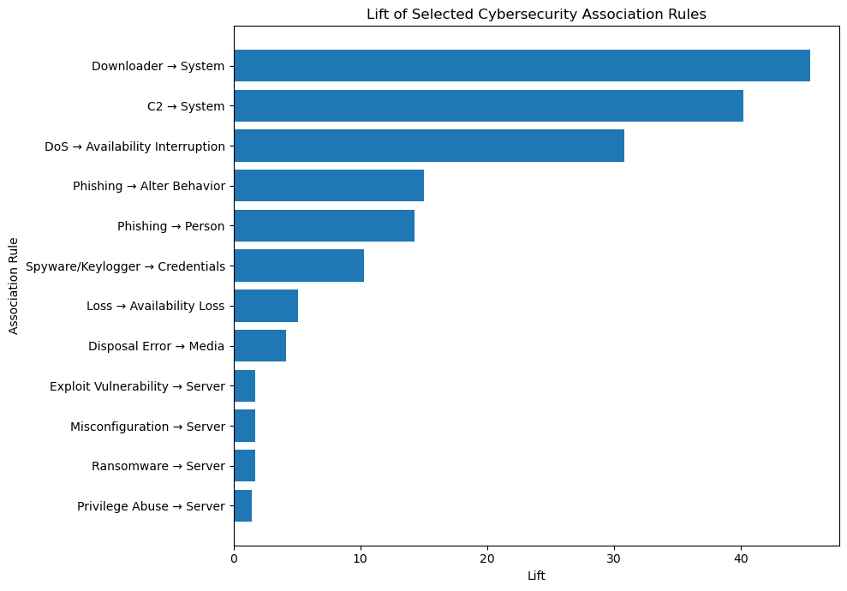
Fig. 1. Lift of selected cybersecurity association rules.
Fig. 2 plots support against confidence for the 12 rules. Rules such as Ransomware → Server and Exploit Vulnerability → Server combine relatively high support with high confidence, while several malware-related rules (e.g., Downloader → System, C2 → System) show high confidence at comparatively low support, reinforcing that support and confidence measure distinct properties of a rule.
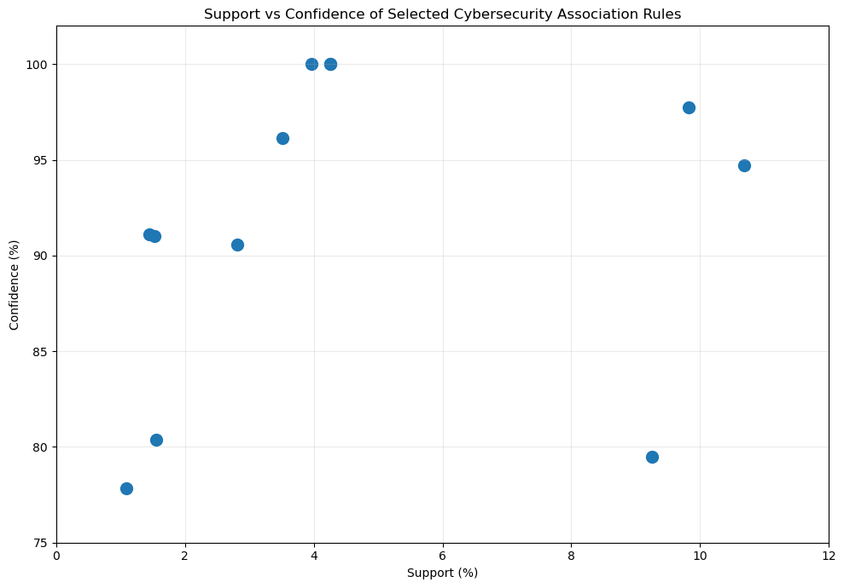
Fig. 2. Support vs. confidence of selected cybersecurity association rules.
Fig. 3 shows the category-wise distribution of the 12 selected rules, corresponding to the percentages in Table II. The graphical results are consistent with the numerical analysis: the selected rules differ considerably in support and lift, with some rules showing high prevalence and others showing comparatively low support but very high lift, reinforcing that support, confidence, and lift must be read together rather than relying on any single measure.
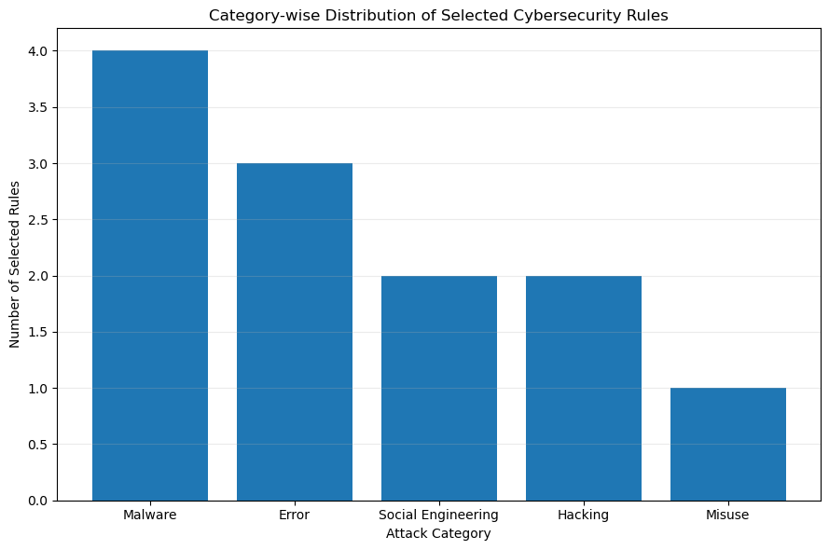
Fig. 3. Category-wise distribution of selected cybersecurity rules.
V. Conclusion and Future Scope
A. Conclusion
This paper presented an Apriori-based analysis of cybersecurity attack patterns using the VERIS Community Database. From 10,596 incidents and 66 selected attributes, Apriori (minimum support 1%, maximum itemset length three) identified 1,183 frequent itemsets and 5,626 association rules; after support, confidence, lift, and attack-oriented filtering, 12 representative rules were selected for analysis. The strongest associations included Downloader → System (lift 45.49), C2 → System (lift 40.18), DoS → Availability Interruption (lift 30.85), and two 100%-confidence phishing rules. These results show that association rule mining can uncover meaningful, interpretable co-occurrence relationships within historical cybersecurity incident data. The discovered rules represent statistical associations within the VCDB records and should not be interpreted as causal or temporal relationships.
B. Contributions of the Study
The study contributes: (i) a reproducible pipeline for transforming high-dimensional VCDB records into a compact, frequency-filtered transaction matrix suitable for Apriori; (ii) a set of 12 representative, cross-category cybersecurity association rules with quantified support, confidence, and lift; and (iii) an explicit interpretive framing that distinguishes co-occurrence from causation and from temporal attack sequencing.
C. Limitations
VCDB is built from publicly reported incidents and may not represent the full population of security incidents. Attribute selection and frequency-based filtering, necessary given the original 2,683-field dataset, exclude rarer characteristics from the final analysis. The discovered rules represent statistical co-occurrence, not causation, and — because each incident is treated as a single transaction without chronological ordering — the rules should not be read as attack sequences or kill-chain stages. High lift values for low-support rules require careful interpretation, and the analysis was restricted to itemsets of at most three attributes, so larger multi-attribute relationships were not explored.
D. Future Scope
Future work can extend this study using larger and more recent VCDB releases or additional cybersecurity datasets; compare Apriori against alternative frequent-itemset algorithms such as FP-Growth for computational efficiency on larger data; explore itemsets larger than three attributes; incorporate sequence-mining techniques to study the order and progression of events, which would differ fundamentally from the present co-occurrence-based approach; combine the discovered associations with classification or clustering methods; and validate the identified patterns against independent cybersecurity datasets to assess their consistency across sources. Any future real-time or monitoring application of these patterns would require dedicated validation and is not implemented or claimed in the present study.
REFERENCES
[1] R. Agrawal, T. Imielinski, and A. Swami, "Mining association rules between sets of items in large databases," in Proc. ACM SIGMOD Int. Conf. Management of Data, 1993, pp. 207–216.
[2] R. Agrawal and R. Srikant, "Fast algorithms for mining association rules in large databases," in Proc. 20th Int. Conf. Very Large Data Bases (VLDB), Santiago, Chile, 1994, pp. 487–499.
[3] A. L. Buczak and E. Guven, "A survey of data mining and machine learning methods for cyber security intrusion detection," IEEE Commun. Surveys Tuts., vol. 18, no. 2, pp. 1153–1176, 2016.
[4] Z. Li, X. Li, R. Tang, and L. Zhang, "Apriori algorithm for the data mining of global cyberspace security issues for human participatory based on association rules," Front. Psychol., vol. 11, art. 582480, Feb. 2021.
[5] M. S. Abu, S. R. Selamat, R. Yusof, and A. Ariffin, "An attribution of cyberattack using association rule mining (ARM)," Int. J. Adv. Comput. Sci. Appl., vol. 11, no. 2, pp. 352–360, 2020.
[6] P. Lou, G. Lu, X. Jiang, Z. Xiao, J. Hu, and J. Yan, "Cyber intrusion detection through association rule mining on multi-source logs," Appl. Intell., vol. 51, no. 6, pp. 4043–4057, 2021.
[7] M. R. Rahman and L. Williams, "Investigating co-occurrences of MITRE ATT&CK techniques," arXiv:2211.06495, 2022.
[8] VERIS Community Database (VCDB), Verizon Risk Team. [Online]. Available: http://veriscommunity.net/vcdb.html

